ANNEX 5
Mind map - example
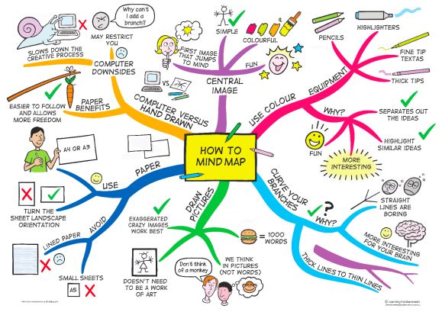
(HILBURN ACADEMY AIG: http://hilburnaig.weebly.com/blog/mind-maps-a-thinking-tool)

